Analogue Lab 1 Report
Introduction
This experiment involved using PSPICE software to simulate basic DC circuit analysis, focusing on setting up and running simulations to determine voltage and current values across circuit components. This is relevant to the real world as I will need to troubleshoot electronic circuits I design before producing them to ensure everything works as it should. The exercise also helped prove Ohm’s Law, Kirchhoff’s Voltage Law (KVL), and Kirchhoff’s Current Law (KCL) as the results produced lined up with the theoretical calculations made using the stated laws.
Background
The main principles used in the electrical circuit were Ohm’s Law, KVL and KCL. KVL state that the Voltage in a series circuit is shared and in parallel is the same. KCL states that current is shared in parallel but the same in series. Ohms law states that voltage is directly proportional to current, and this is governed by the equation;

V = IR
V means voltage measured in volts (V), I means current measured in amps (A),
R means resistance measured in ohms (Ω)

Methodology
In this lab I used PSPICE to stimulate the circuits in this report. Before beginning the simulation, I did theoretical calculations to work out the current and voltage through the circuit^{(Fig:1&2)} so I could later compare them to the simulation. After that I set up the PSPICE software by making a new project and ensuring the correct libraries were loaded. Then I made my schematic by placing the components on the boards, setting their values and wiring them together. Once the circuit was built, I configured the simulation profile for DC analysis and ran the simulation to see the voltage and current at certain parts of the circuit^{(Fig:3)}
I then changed the circuit by adding in a R3 in parallel to R2^{(Fig:4)}, the resistance of this resistor was made into a parameter {RES1} using DC Sweep to vary the resistance from 100Ω to 1000Ω with a step of 10Ω, after this was done we configured PSPICE to recognize the parameter and ran the simulation to analyze the results and compare them to the theoretical calculations we had made^{(Fig:5)}.

Results
So as seen on Figure 2, the voltage going into R2 was calculated to be 8v and the current in the circuit was calculated to be 20mA. This is backed by my simulation in Figure 3 which has the same values.
For the second circuit seen on Figure 4, I calculated the change in voltage and current as the values of R3 changed and graphed the values of the change in voltage to Figure 7 and the change in current of each resistor to Figure 8. In the theoretical calculations to compare the results I set the value of R3 to 400Ω and did the calculations for voltage and power which can be seen in Figure 5. From the Theoretical calculation I worked out the Voltage at R3 was found to be 6.67v and using this value I worked out the power was 0.11w. This is backed by my simulation in Figure 7&6 which have the same values.
Also to finish off the results the current in each resistor as shown in Figure 8 also supports KCL as it shows that the current in the circuit is shared between R2 and R3 as when the values are added together, we get the value for R1. And the value of current at R3 when its 400Ω can also be used in conjunction with the equation for power (P =IV where P is power measured in watts (w)) to support the 0.11W found in our theoretical calculation.
Conclusion
In conclusion the Lab was successful as the results that were obtained from the PSPICE software were the results that corelated to the theoretical calculations. The results can now be used to verify the legitimacy of ohm’s law, KVL, and KCL and their application in physical circuits.
Figures
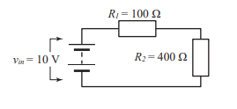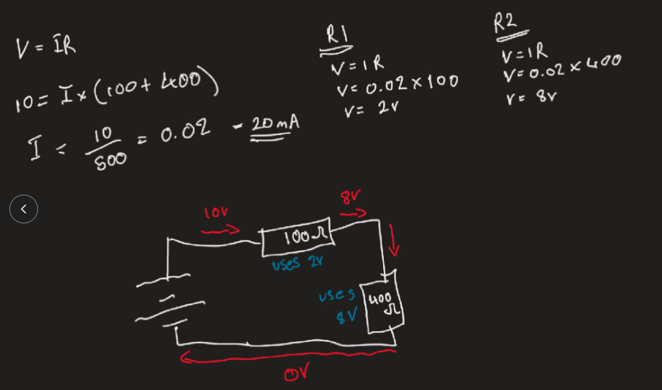
Fig:1
Fig:2
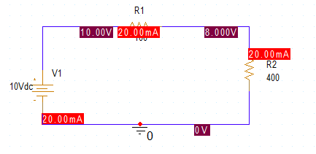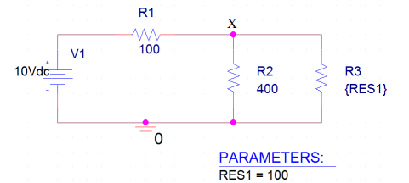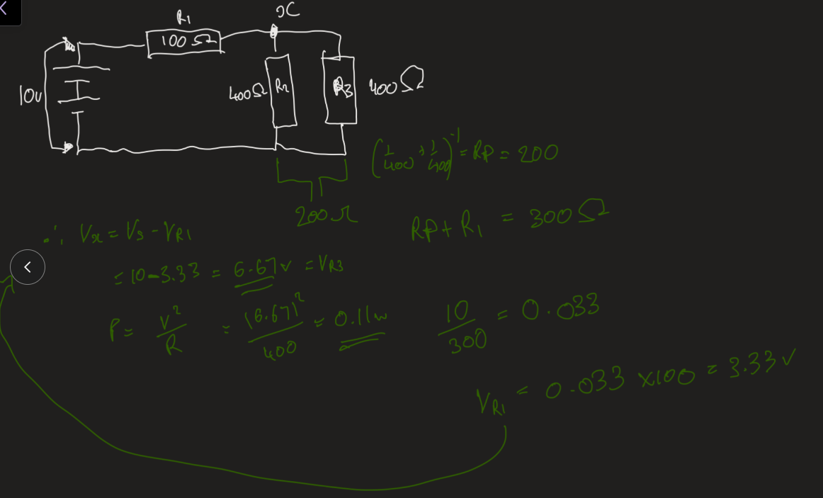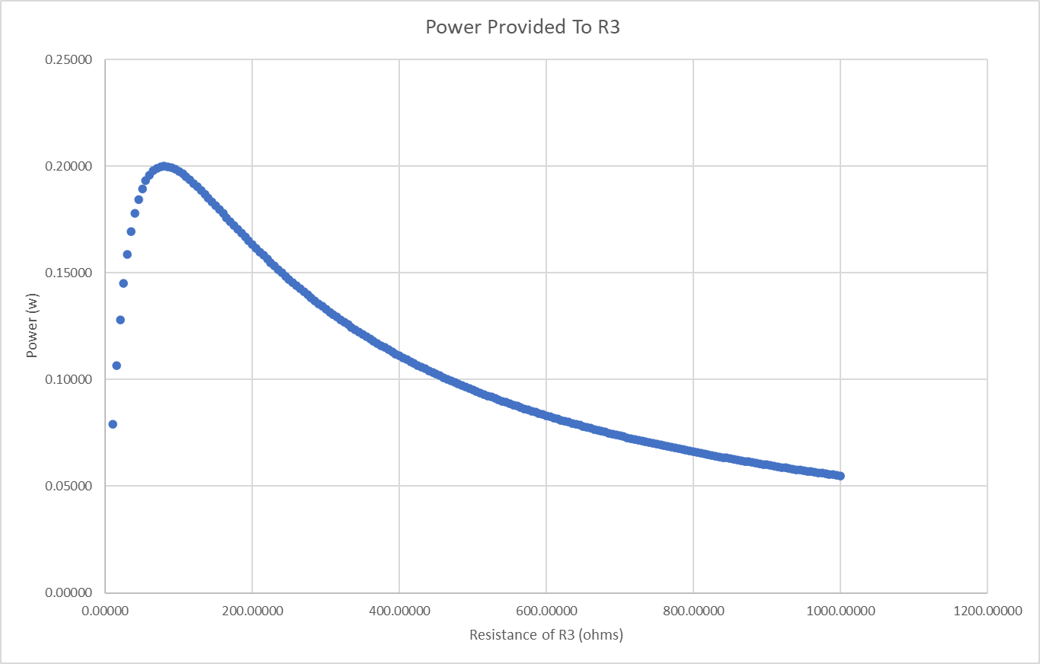
W
R
Fig
Fig:3
Fig:4
Fig: 5
Fig:6
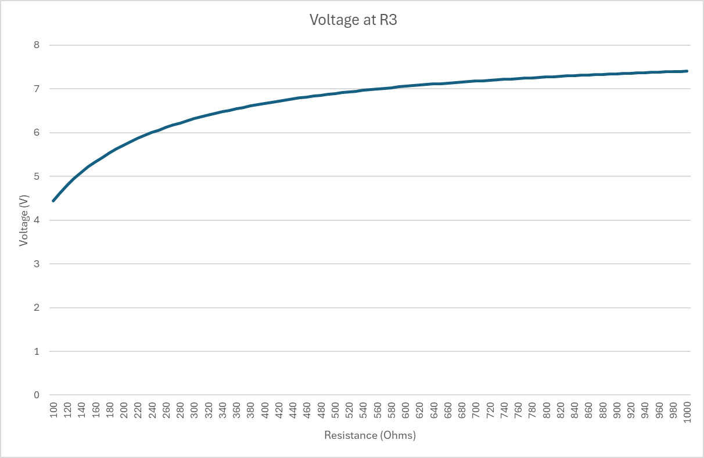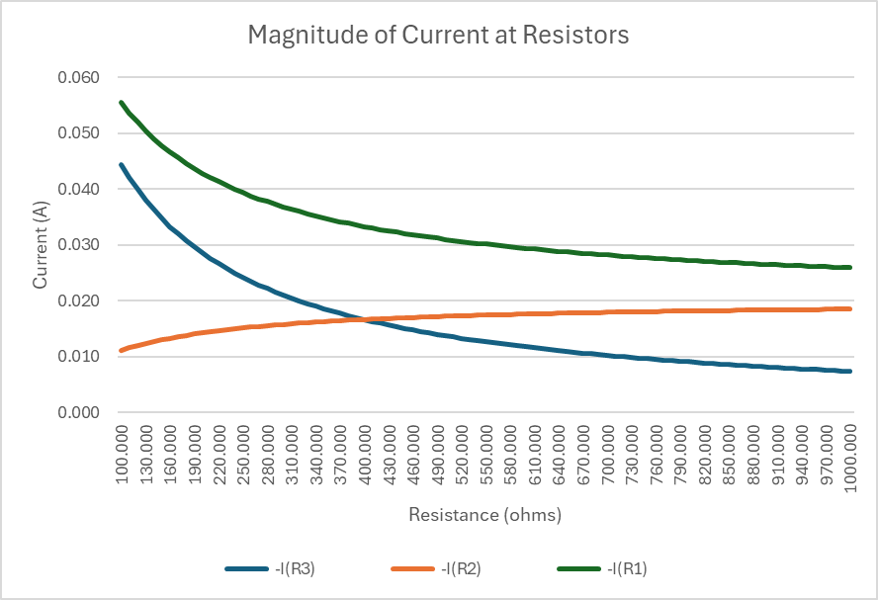
I_{R1}

I_{R2}

I_{R3}
R
P
R
Fig: 7
Fig: 8

